
Department of Computer Science

Software Requirements Specification

Smart Academic Advisory and Support Prediction

Supervisor:
Mrs. I.N Ezeji

Submitted by

Student Name | Student Number
- Nhlanhlenhle Ngcobo | 240035192
- Celimpilo Dlamini | 202020444
- Zinhle Mhlongo | 202285904
- Mphilisi Hlandze | 230013633
- Nokwanda Sibiya | 230015229
- Thandiwe Mvelase | 240111090

Date: 02 September 2026

1.0 Introduction
1.1 Purpose
The purpose of this document is to present a detailed description of the Smart Academic Advising and Student Support Platform (SAASSP). It explains the purpose and the functional features, interface requirements, machine learning risk classification capabilities, and rule-based module eligibility logic of the system. This specification serves as the formal baseline for development, validation, and evaluation by academic supervisors and project stakeholders.
1.2 Scope of Project
SAASSP is a web-based decision-support system specifically tailored to the Bachelor of Science in Computer Science (BSCCS - 176 total credits) curriculum at UNIZULU. The system is designed to improve academic planning and support by automating academic progress checks, module eligibility checks, recommendations, checks qualification progress and academic risk classification.
Key features include:
• Student self-service progress tracking, prerequisite and co-requisite eligibility checks, and automated module registration recommendations.
• Machine learning classification of academic risk levels (High, Medium, Low) derived from historical performance, attendance, and continuous assessment data (utilizing non-leakage feature engineering).
• Academic Staff advising dashboards providing detailed risk outputs, credit progression tracking, and visual analytics reports.
• Operational deployment on a local web technology stack (Python backend, Node.js microservices, MySQL database via XAMPP).

1.3 Glossary
Term | Definition
SAASSP | Smart Academic Advising and Student Support Platform
BSCCS | Bachelor of Science in Computer Science degree program at UNIZULU (176 credits total).
Co-requisite | A module that must be taken concurrently with or prior to another module.
Prerequisite | A module that must be successfully passed before enrolling in a subsequent module.
ML Risk Classification | Supervised machine learning model output categorizing a student into High, Medium, or Low academic risk.
Rule-Based Engine | Deterministic logic validating credit tallies, prerequisites, and co-requisites based on the academic handbook.
Academic Staff | Academic advisor or lecturer who reviews student information and supports academic interventions.
1.4 References
[1] IEEE Std 830-1998, IEEE Recommended Practice for Software Requirements Specifications, IEEE Computer Society, 1998.
[2] Department of Computer Science, Undergraduate Student Handbook & Curriculum Rules, University of Zululand, 2026.
[3] SAASSP Project Proposal & System Architecture Specification, 2026.
1.5 Overview of Document
The remainder of this document is organized as follows: Section 2 provides an Overall Description of the system context, system diagrams, actor characteristics, and general constraints. functionalize the Detailed Requirements Specification, fully detailing functional use case tables for all Student and Academic Staff interactions, external interfaces, and non-functional standards.
2.0 Overall Description
2.1 System Environment
SAASSP operates as a web application connected to a MySQL relational database (hosted locally via XAMPP). The backend combines a Python API service (handling ML risk prediction pipelines) and a Node.js web server powering the user interface. Active users interact with the system via standard desktop or mobile web browsers.

.

2.2.1 Student Use Cases
Use Case: Create Student Account

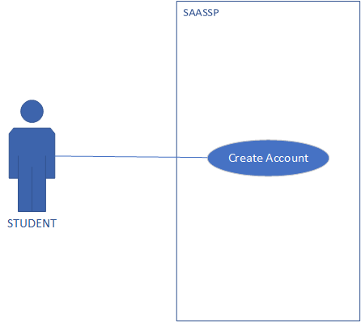
Brief Description:
The student creates a SAASSP account by providing the required account and student information.
Initial Step-by-Step Description:
The student selects Create Account.
The system displays the account-registration form.
The student selects the student account type.
The student enters the required account and student information.
The student enters and confirms a password.
The system validates the supplied information.
The system creates the student account.
The system confirms successful account creation and directs the student to login.

XRef: section 3.2.1 Create Account (Student)
Use Case: Student Login

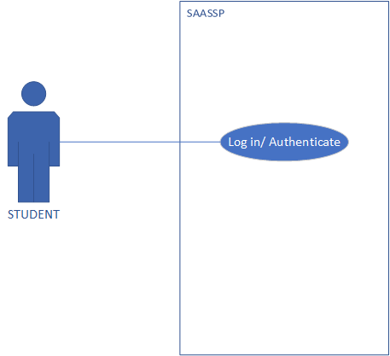
Brief Description:
The student authenticates with SAASSP to gain access to Student functions and the Student Dashboard.
Initial Step-by-Step Description:
The student selects Login.
The system displays the login form.
The student enters a username and password.
The system validates the credentials.
The system determines that the account has the student role.
The system grants authorized access.
The Student Dashboard is displayed.

XRef: 3.2.2 Log in/ Authenticate (student)

Use Case: View Academic Information

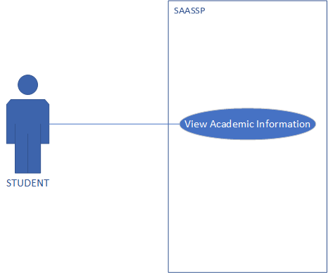
Brief Description:
The student views the academic information contained in their configured academic profile.
Initial Step-by-Step Description:
The student logs into SAASSP.
The student selects the academic information function.
The system identifies the authenticated Student.
The system retrieves the student’s configured academic information.
The system displays information to the student.

XRef: 3.2.3 View Academic information

Use Case: View Outstanding Requirements

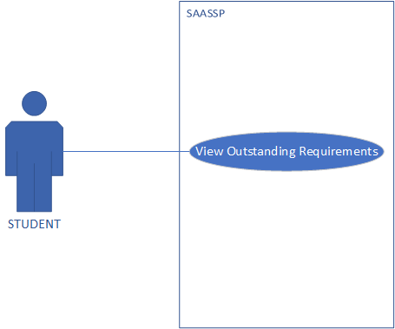
Brief Description:
The student views modules, credits or other configured academic requirements that remain outstanding toward the qualification.
Initial Step-by-Step Description:
The student selects Outstanding Requirements.
The system retrieves the student’s academic record.
The system retrieves the applicable programme structure.
The system compares complete academic requirements with programme requirements.
The system identifies outstanding requirements.
The system displays the outstanding requirements for the student.

XRef: 3.2.4 View Outstanding Requirement

Use Case: Check Module Eligibility
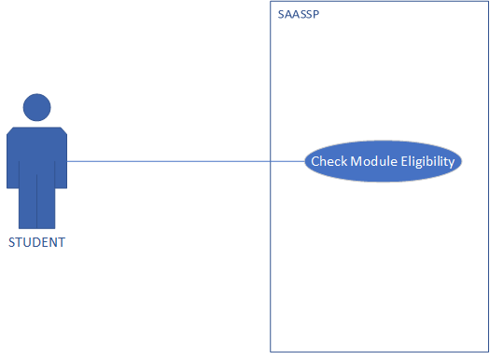
Brief Description:
The student checks whether they are indicatively eligible to take a selected module based on configured academic rules.
Initial Step-by-Step Description:
The student selects Module Eligibility.
The system displays applicable modules.
The student selects a module.
The system retrieves the student’s academic record.
The system checks the module's prerequisites.
The system checks the module's co-requisites.
The system checks relevant module-completion and programme conditions.
The system determines the student’s indicative eligibility.
The system displays eligibility results.

XRef: 3.2.5 Check Module Eligibility

Use Case: View Recommendation

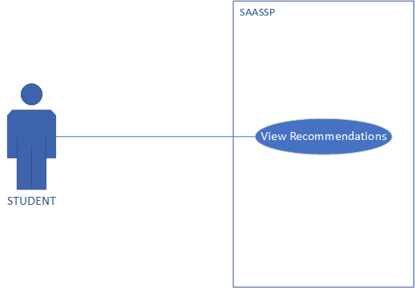

Brief Description:
The student views an explanation showing why a module has been recommended or excluded.
Initial Step-by-Step Description:
The student views module-recommendation results.
The student selects a recommended or excluded module.
The system retrieves the rules used in determining the result.
The system generates or retrieves the applicable explanation.
The system displays the reason for the recommendation or exclusion.

XRef: 3.2.6 View Recommendations

Use Case: View Qualification Progress

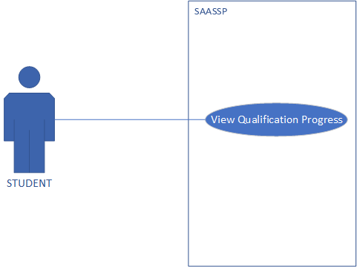
Brief Description:
The student views indicative progress toward completing the configured qualification.
Initial Step-by-Step Description:
The student selects Qualification Progress.
The system retrieves the student’s academic record and programme structure.
The system calculates accumulated credits.
The system calculates outstanding credits.
The system identifies outstanding modules or requirements.
The system calculates indicative qualification progress.
The system displays progress information to the student.

XRef: 3.2.7 View Qualification Progress

Use Case: View Academic Risk Classification
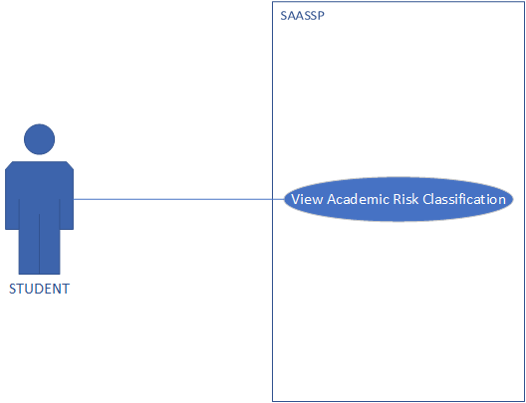
Brief Description:
The student views the experimental academic-risk classification associated with the applicable synthetic student profile.
Initial Step-by-Step Description:
The student selects Academic Risk Insights.
The system retrieves the applicable synthetic academic information.
The system retrieves or generates experimental risk classification.
The system displays the academic-risk category and available supporting information.
The system indicates that the result is experimental and based on synthetic data.

XRef: 3.2.8 View Academic Risk Classification

Use Case: Student Log Out
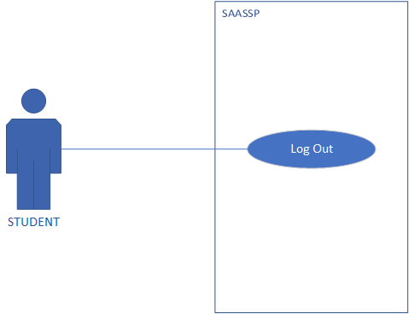
Brief Description:
The student ends the authenticated SAASSP session.
Initial Step-by-Step Description:
The student selects Logout.
The system terminates the authenticated session.
The system removes access to protected Student functions.
The system returns the student to the public/login interface.

XRef: 3.2.9 Log Out (student)

2.2.2 Academic Staff Use Cases
Use Case: Create Academic Staff Account
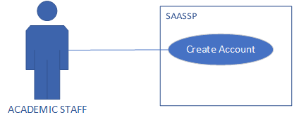
Brief Description:
An Academic Staff member creates an authorized SAASSP account using the required account and staff information.
Initial Step-by-Step Description:
The Academic Staff member selects Create Account.
The system displays the registration form.
The user selects Academic Staff as the account type.
The user enters the required staff and account information.
The user submits the registration information.
The system validates information.
The system creates an Academic Staff account where permitted.
The system directs the user to login.

XRef: 3.2.10 Create Account (Academic Staff)

Use Case: Academic Staff Login

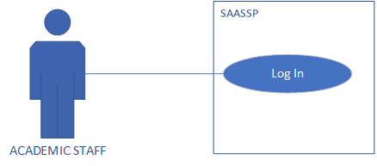
Brief Description:
Academic Staff authenticate with SAASSP to access authorized Academic Staff functions.
Initial Step-by-Step Description:
Academic Staff selects Login.
The system displays the login interface.
Academic Staff enters valid credentials.
The system validates the credentials.
The system confirms the Academic Staff role.
The system grants authorized access.
The Academic Staff Dashboard is displayed.

XRef: 3.2.11 Log In (Academic Staff)

Use Case: Review Student Academic Information
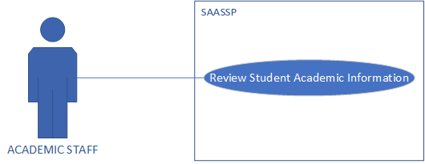
Brief Description:
Academic Staff review the configured academic information of a selected synthetic student profile.
Initial Step-by-Step Description:
Academic Staff select Student Records.
The system displays available authorized student records.
Academic Staff selects a student.
The system retrieves the selected Student's academic information.
The system displays academic information for review.

XRef: 3.2.12 Review Student Academic Information

Use Case: Review Recommendation

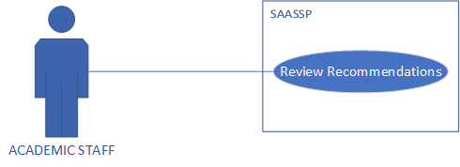
Brief Description:
Academic Staff review rule-based module recommendations generated for a selected Student.
Initial Step-by-Step Description:
Academic Staff selects a student record.
Academic Staff selects the recommendation information.
The system retrieves or generates the students’ recommendation results.
The system displays recommended and excluded modules.
Academic Staff reviews the decision-support output.

XRef: 3.2.13 Review Recommendation

Use Case: Review Qualification Progress

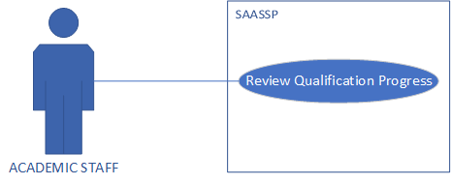
Brief Description:
Academic Staff review a student’s indicative qualification-progress information.
Initial Step-by-Step Description:
Academic Staff selects a student.
Academic Staff opens Qualification Progress.
The system retrieves the student’s academic record and programmer structure.
The system calculates or retrieves accumulated and outstanding credits.
The system identifies outstanding requirements.
The system displays indicative qualification progress.
Academic Staff reviews the information.

XRef: 3.2.14 Review Qualification Progress

Use Case: Review Academic Risk Outputs

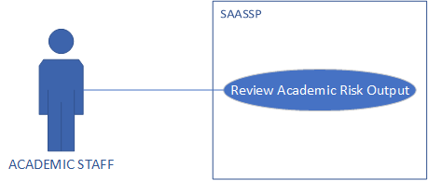
Brief Description:
Academic Staff review experimental academic-risk classifications generated using synthetic student information.
Initial Step-by-Step Description:
Academic Staff select Risk Insights.
The system retrieves available experimental risk outputs.
Academic Staff selects a relevant Student profile where applicable.
The system displays experimental academic-risk classification.
The system indicates the synthetic-data and experimental nature of the result.
Academic Staff reviews the output.

XRef: 3.2.15 Review of Academic Risk Output

Use Case: View Reports Visualizations

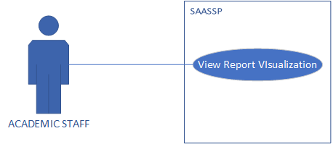
Brief Description:
Academic Staff view basic reports and visualizations produced from information available within the SAASSP prototype.
Initial Step-by-Step Description:
Academic Staff selects Reports.
The system retrieves the required available information.
The system processes the information for reporting.
The system generates the applicable report or visualization.
The system displays the results to Academic Staff.

XRef: 3.2.16 View Report Visualization

Use Case: Academic Staff Logout

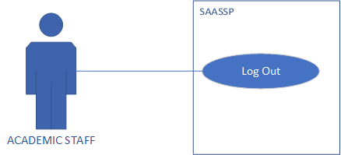
Brief Description:
Academic Staff terminate the authenticated SAASSP session.
Initial Step-by-Step Description:
Academic Staff selects Logout.
The system terminates the session.
Protected Academic Staff functions become unavailable.
The system returns to the public/login interface.

XRef: Section 3.2.17 Log Out (Academic Staff)

2.2.3 System Administrator Use Cases
Use Case: Create Account

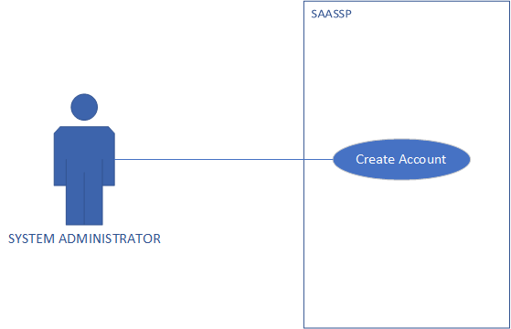
Brief Description:
The System Administrator creates a new user account so that an authorized student or staff member can access SAASSP.
Initial Step-By-Step Description:
The System Administrator selects the user account management function.
The System displays the account creation form.
The System Administrator enters the required user details.
The System validates the supplied information and checks for an existing account.
The System creates and securely stores the new account.

XRef: 3.2.19 System Administrator (create account)

Use Case: Log In/Authentication
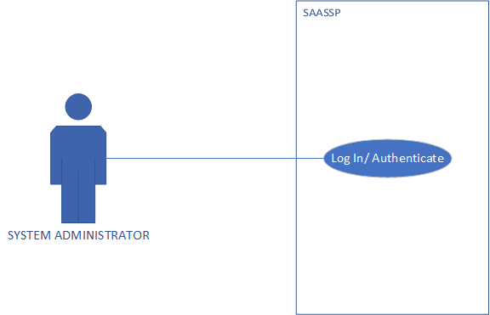
Brief Description:
The System Administrator authenticates SAASSP to access authorized administrative functions.
Initial Step-by-Step Description:
The Administrator opens the login page.
The Administrator enters authorized credentials.
The system validates the credentials.
The system verifies the Administrator role.
The system grants administrative access.
The Administration Dashboard is displayed.

XRef: Section 3.2.20 Log In/ Authenticate

Use Case: Manage User Accounts
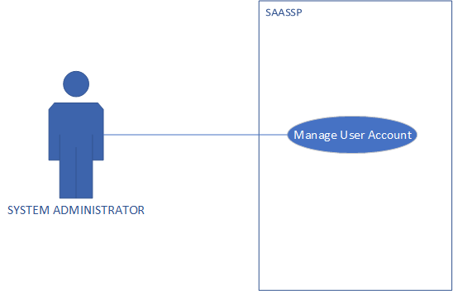

Brief Description:
The System Administrator maintains authorized SAASSP user accounts.
Initial Step-by-Step Description:
The Administrator selects User Accounts.
The system displays existing user-account information.
The Administrator selects the required account-management action.
The Administrator enters or updates the applicable information.
The system validates information.
The system stores the changes.
The system confirms the operation.

XRef: 3.2.21 Manage User Account

Use Case: Manage Program Information
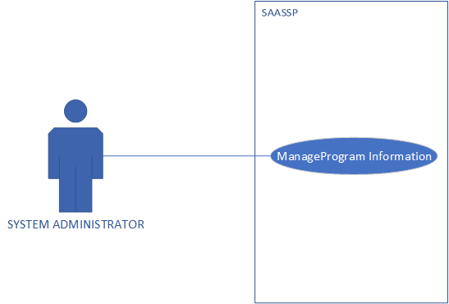
Brief Description:
The System Administrator creates and maintains program information used by SAASSP.
Initial Step-by-Step Description:
The Administrator selects Program Management.
The system displays configured program information.
The Administrator selects to add or update a program
The Administrator enters the required program information.
The system validates information.
The system stores the programed information.

XRef: Section 3.2.22 Manage Program Management

Use Case: Manage Module Information
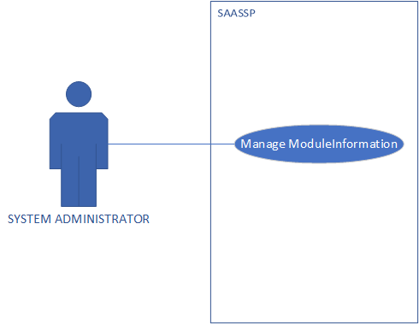
Brief Description:
The System Administrator maintains the module information associated with configured academic programs.
Initial Step-by-Step Description:
The Administrator selects Module Management.
The system displays configured modules.
The Administrator selects to add or update a module.
The Administrator enters module information.
The Administrator associates the module with the appropriate programme.
The system validates information.
The system stores the changes.

XRef: Section 3.2.23 Manage Module Information

Use Case: Manage Prerequisite Rules
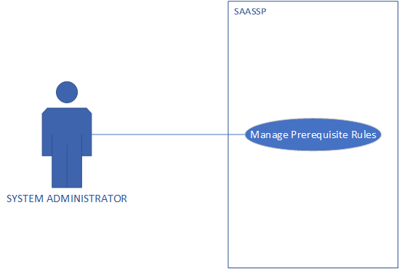
Brief Description:
The System Administrator maintains prerequisite relationships used when checking module eligibility.
Initial Step-by-Step Description:
The Administrator selects the prerequisite-management function.
The system displays configured module prerequisite relationships.
The Administrator selects a module.
The Administrator adds, updates or removes an applicable prerequisite.
The system validates the relationship.
The system stores the updated prerequisite rule.

XRef: Section 3.2.24 Manage Prerequisite Rules

Use Case: Manage Co-requisite Rules
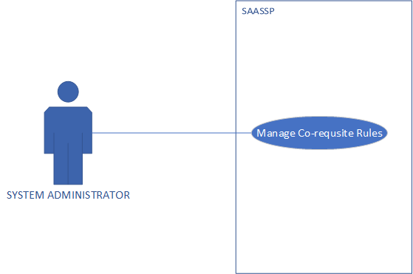

Brief Description:
The System Administrator maintains co-requisite relationships used by the module-eligibility process.
Initial Step-by-Step Description:
The Administrator selects the co-requisite management function.
The system displays configured co-requisite relationships.
The Administrator selects the applicable module.
The Administrator adds, updates or removes a co-requisite.
The system validates the relationship.
The system stores the rules.

XRef: Section 3.2.25 Manage Co-requisite Rules

Use Case: Manage Academic Rules
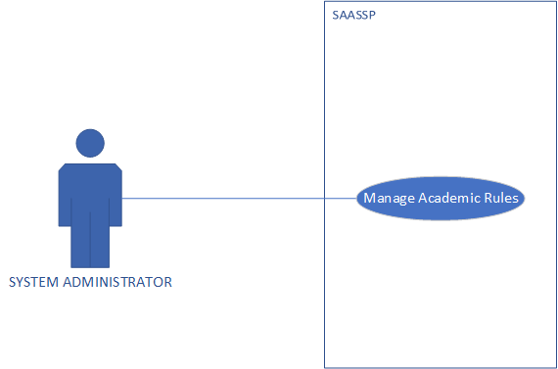

Brief Description:
The System Administrator maintains other configured academic rules required by SAASSP's decision-support functions.
Initial Step-by-Step Description:
The Administrator opens the academic-rule management function.
The system displays configured academic rules.
The Administrator selects a rule to add or modify.
The Administrator enters the required information.
The system validates the rules.
The system stores the updated configuration.

XRef: Section 3.2.26 Manage Academic Rules
Use Case: Manage Student Records
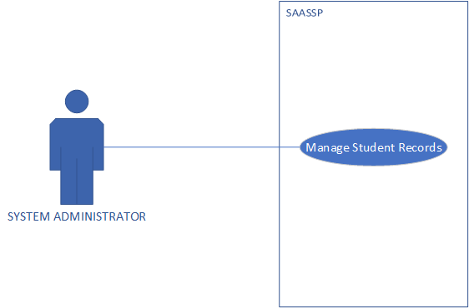
Brief Description:
The System Administrator creates and maintains synthetic student records used by the SAASSP prototype.
Initial Step-by-Step Description:
The Administrator selects Synthetic Student Records.
The system displays available synthetic records.
The Administrator selects to create or update a record.
The Administrator enters the required synthetic academic information.
The system validates information.
The system stores the synthetic record.
The information becomes available to applicable decision-support functions.

XRef: Section 3.2.27 Manage Student Records

Use Case: Log Out
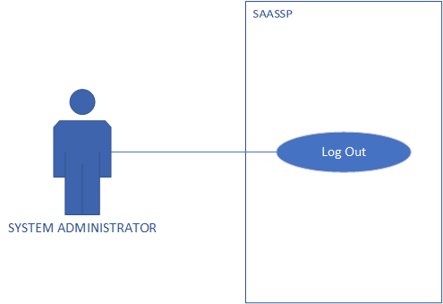

Brief Description:
The System Administrator terminates the authenticated administrative session.
Initial Step-by-Step Description:
The Administrator selects Logout.
The system terminates the authenticated session.
Administrative functions become inaccessible.
The system returns to the public/login interface.

XRef: Section 3.2.28 Log Out

2.3 User Characteristics
• Student: Undergraduate computer science students. Expected to possess standard web browsing skills to view performance, check module prerequisites, and view automated advising recommendations.
• Academic Staff (Advisor/Lecturer): Academic personnel in the Computer Science department. Expected to be proficient in interpreting academic performance metrics, evaluating ML risk predictions, and managing advising interventions.
2.4 Non-Functional Requirements Overview
• Performance: Database queries for eligibility and recommendations must execute in under 2 seconds.
• Reliability: The system must enforce data integrity, ensuring rule checks strictly mirror handbook logic.
• Usability: Responsive web layout with intuitive navigation tailored for both desktop and mobile screens.

3.0 Detailed Functional Requirements

3.1 External Interface Requirements
• User Interface: Standard HTML5/CSS/JavaScript responsive interface.
• Database Interface: MySQL relational database accessed via SQLAlchemy/PyMySQL in Python and MySQL2 driver in Node.js.
• Machine Learning Model Interface: Scikit-learn serialized pipeline loaded dynamically for real-time risk inference.

3.2 Functional Requirements
The following detailed functional requirements correspond to the use cases summarized in section 2.2. Each use requirement table follows the structure of the supplied SRS sample by identifying the use case, XRef, trigger, precondition, basic path, alternatives path, postcondition and exception paths.
Use Case: Create Account (Student)
Use Case Name | Create Account (Student)
XRef | Section 3.2.1
Trigger | Students access the registration page of SAASSP.
Precondition | Student possesses a valid UNIZULU student number and institutional email address.
Basic Path | 1. Student navigates to the registration portal.  2. System presents account creation form (Student ID, Name, Email, Password, Program).  3. Student enters required details and submits form.  4. System validates student ID format, checks for existing accounts, and hashes password.  5. System creates student accounts and displays success confirmation.
Alternative Paths | • If Student ID already exists, system displays an error prompt to log in instead.
Postcondition | New student account is securely stored in the database.
Exception Paths | • Invalid input format or blank required fields result in validation warnings and form reset.

Use Case: Log In / Authenticate (Student)
Use Case Name | Log In / Authenticate (Student)
XRef | Section 3.2.2
Trigger | Students visit SAASSP login page.
Precondition | Students have an active registered account.
Basic Path | 1. Student enters Student ID and password.  2. Student clicks 'Log In'.  3. System authenticates credentials against stored password hashes.  4. System creates user sessions and redirects students to the Student Dashboard.
Alternative Paths | • Student clicks 'Forgot Password' to initiate password reset via institutional email.
Postcondition | Authenticated session is established for the student.
Exception Paths | • Incorrect credentials display an 'Invalid ID or Password' error message.

Use Case: View Academic Information
Use Case Name | View Academic Information
XRef | Section 3.2.3
Trigger | Student selects 'Academic Record' on dashboard.
Precondition | Students are authenticated and logged into the system.
Basic Path | 1. Student requests to view academic profile.  2. System queries database for completed modules, marks, credits earned, and current GPA.  3. System presents a structured, semester-by-semester academic breakdown.
Alternative Paths | • Student applies filters by academic level (Year 1, Year 2, Year 3).
Postcondition | Students view complete academic summary.
Exception Paths | • If database connection fails, system displays a friendly service error.

Use Case: View Outstanding Requirements
Use Case Name | View Outstanding Requirements
XRef | Section 3.2.4
Trigger | Student clicks 'Outstanding Requirements' menu option.
Precondition | Students are authenticated and active degree program (BSCCS) is identified.
Basic Path | 1. Student initiates outstanding requirements check.  2. System compares completed modules against the 176-credit BSCCS curriculum structure.  3. System compiles list of remaining compulsory and elective modules required for graduation.  4. System displays remaining credit tally per module group.
Alternative Paths | • None.
Postcondition | Outstanding curriculum requirements are clearly presented.
Exception Paths | • Curriculum rule mapping missing results in error prompts to contact advisor.

Use Case: Check Module Eligibility
Use Case Name | Check Module Eligibility
XRef | Section 3.2.5
Trigger | Students select a specific module to evaluate eligibility.
Precondition | Student is logged in and module prerequisite/co-requisite database rules are configured.
Basic Path | 1. Student searches or selects a module (e.g., 4CPS212).  2. System retrieves prerequisite rules (e.g., passed 4CPS111) and co-requisites.  3. System evaluates student's past results against rules.  4. System displays eligibility status ('Eligible' or 'Ineligible with reason').
Alternative Paths | • If student lacks prerequisite, system details specific missing module(s).
Postcondition | Student receives explicit verification of module eligibility.
Exception Paths | • Unrecognized module code displays 'Module Not Found' prompt.

Use Case: View Recommendations
Use Case Name | View Recommendations
XRef | Section 3.2.6
Trigger | Student navigates to 'Advising Recommendations' tab.
Precondition | Students have completed eligibility and progress evaluation.
Basic Path | 1. Student requests registration recommendations.  2. System executes rule-based engine considering prerequisites, credit limits, and timetable constraints.  3. System generates an optimized recommended list of modules for the upcoming semester.  4. System displays recommended module set with reasoning.
Alternative Paths | • Student can download or print the recommendation summary.
Postcondition | Automated academic recommendation is rendered.
Exception Paths | • Incomplete academic record alerts students to verify official marks.

Use Case: View Qualification Progress
Use Case Name | View Qualification Progress
XRef | Section 3.2.7
Trigger | Students select 'Qualification Progress'.
Precondition | Students are authenticated.
Basic Path | 1. Student accesses qualification progress screen.  2. System calculates total earned credits vs. total required credits (176 credits).  3. System renders a visual progress bar indicating completion percentage.
Alternative Paths | • None.
Postcondition | Degree progress completion percentage is displayed.
Exception Paths | • Calculation error triggers fallback tabular credit summary.

Use Case: View Academic Risk Classification
Use Case Name | View Academic Risk Classification
XRef | Section 3.2.8
Trigger | Students open 'Academic Performance & Risk' panel.
Precondition | ML risk inference model has processed eligible student records (ml_eligible = 1).
Basic Path | 1. Student clicks to check academic risk status.  2. System retrieves latest ML classification (Low, Medium, High Risk) from risk predictions table.  3. System displays risk levels alongside constructive academic support advice.
Alternative Paths | • High-risk students are presented with a direct button to schedule an advising session.
Postcondition | Academic risk level and guidance are displayed.
Exception Paths | • If student data is pending ML evaluation, system displays 'Assessment Pending'.

Use Case: Log Out (Student)
Use Case Name | Log Out (Student)
XRef | Section 3.2.9
Trigger | Student clicks 'Log Out' button.
Precondition | Students are currently logged into an active session.
Basic Path | 1. Student selects Log Out option.  2. System terminates active session and clears session tokens.  3. System redirects users back to the public login page.
Alternative Paths | • None.
Postcondition | Student session is securely terminated.
Exception Paths | • Session timeout automatically executes logout.

Use Case: Create Account (Academic Staff)
Use Case Name | Create Account (Academic Staff)
XRef | Section 3.2.10
Trigger | Staff member opens staff registration page.
Precondition | Staff members possess authorized staff registration token.
Basic Path | 1. Academic staff enters staff credentials, department, and registration token.  2. System validates staff token and details.  3. System creates academic staff accounts and confirms registration.
Alternative Paths | • None.
Postcondition | New academic staff user is created.
Exception Paths | • Invalid staff token displays unauthorized access error.

Use Case: Log In (Academic Staff)
Use Case Name | Log In (Academic Staff)
XRef | Section 3.2.11
Trigger | Academic staff visits login portal.
Precondition | Staff members have registered account.
Basic Path | 1. Staff enter staff ID/email and password.  2. System verifies credentials and grants access.  3. System redirects staff to Academic Advisor Portal.
Alternative Paths | • Password recovery process via university email.
Postcondition | Staff session established.
Exception Paths | • Credentials failure prompts re-entry.

Use Case: Review Student Academic Information
Use Case Name | Review Student Academic Information
XRef | Section 3.2.12
Trigger | Staff inputs student ID or selects student from cohort list.
Precondition | Staff members are logged into advisor portal.
Basic Path | 1. Staff searches for a specific student record.  2. System retrieves full academic history, module marks, attendance records, and credit breakdown.  3. System displays comprehensive student academic profile.
Alternative Paths | • Staff filters student search by year level or risk category.
Postcondition | Full student academic record displayed for review.
Exception Paths | • Student ID not found displays search error.

Use Case: Review Recommendation
Use Case Name | Review Recommendation
XRef | Section 3.2.13
Trigger | Staff opens student advising tab.
Precondition | Student profile selected.
Basic Path | 1. Staff clicks 'View Automated Recommendation' for selected student.  2. System renders rule-based module recommendations alongside prerequisite eligibility statuses.  3. Staff reviews and endorses or adjusts advice.
Alternative Paths | • Staff appends manual advising notes to student record.
Postcondition | Advising recommendation reviewed and saved.
Exception Paths | • Missing prerequisite rules trigger system warning.

Use Case: Review Qualification Progress
Use Case Name | Review Qualification Progress
XRef | Section 3.2.14
Trigger | Staff selects qualification tracking view.
Precondition | Student profile active.
Basic Path | 1. Staff evaluates student's degree completion state.  2. System presents detailed breakdown of completed vs. outstanding credits against 176 BSCCS total.  3. System flags potential graduation delays if core modules are outstanding.
Alternative Paths | • None.
Postcondition | Qualification progress audit completed.
Exception Paths | • Data mismatch highlights manual review flag.

Use Case: Review Academic Risk Output
Use Case Name | Review of Academic Risk Output
XRef | Section 3.2.15
Trigger | Staff accesses 'Risk Assessment' module.
Precondition | ML risk classification model executed.
Basic Path | 1. Staff views cohort-wide or individual student risk flags (High, Medium, Low).  2. System displays key contributing factors (e.g., attendance < 75%, failed prerequisites).  3. Staff identify high-risk students requiring early intervention.
Alternative Paths | • Staff exports high-risk student list for departmental intervention.
Postcondition | Risk classifications reviewed for targeted student support.
Exception Paths | • Uncalculated risk triggers manual recalculation prompt.

Use Case: View Report Visualization
Use Case Name | View Report Visualization
XRef | Section 3.2.16
Trigger | Staff selects 'Analytics & Reports' tab.
Precondition | Staff are logged in.
Basic Path | 1. Staff requests visual analytics reports.  2. System generates visual charts (risk distribution pie chart, module pass rate histograms, credit progress trends).  3. System presents interactive dashboard graphics.
Alternative Paths | • Staff filters visualization by semester or academic year.
Postcondition | Visual report displayed.
Exception Paths | • Data extraction error displays empty report message.

Use Case: Log Out (Academic Staff)
Use Case Name | Log Out (Academic Staff)
XRef | Section 3.2.17
Trigger | Staff clicks 'Log Out'.
Precondition | Active staff session.
Basic Path | 1. Staff clicks logout button.  2. System destroys active session.  3. User redirected to login screen.
Alternative Paths | • None.
Postcondition | Staff session terminated.
Exception Paths | • Automatic timeout after period of inactivity.

Use Case: (System Administrator) Create Account
Use Case Name | Create Account
XRef | Section 3.2.18
Trigger | System Administrator selects the Create Account function.
Precondition | System Administrator is authenticated and authorized to create user accounts.
Basic Path | 1.System Administrator selects Create Account.  2.System displays the account creation form.  3.System Administrator enters the required user details.  4.System Validates the information and checks whether an account already.  5.System securely creates and stores the new account.
Alternative Paths | If the account details are incomplete or an account already exists, the system displays an error message and requests correction.
Postcondition | A new user account is securely stored in the database.
Exception Paths | Missing required fields, duplicate account details, or invalid information prevent account creation.

Use Case: Log In/Authentication
Use Case Name | Log in/ authentication
XRef | Section 3.2.19
Trigger | System administrator accesses the SAASSP login page
Precondition | System administrator has a valid administrator username and password
Basic Path | 1.System Administrator navigates to the SAASSP login page.  2.System display the login details.  3.System Administrator enters the administration username and password.  4.System validates the supplied credentials.  5.System grants access to the System Administrator functions.
Alternative Paths | If the credentials are invalid, the system displays an error message and request the System Administrator to try again.
Postcondition | The System Administrator is securely authenticated and granted access to administrative functions.
Exception Paths | Blank or invalid credentials result in validation warnings and access is denied.

Manage User Account
Use Case Name | Manage User Account
XRef | Section 3.2.20
Trigger | System administrator selects the Manage user Account function.
Precondition | System Administrator is authenticated and authorized to manage user accounts.
Basic Path | 1.System Administrator selects Manage User Accounts.  2.System display the available user accounts and account-management options.  3. System Administrator creates a new account or select an existing account to update.  4.System Administrator enters or updates the required account information.  5.System validates the information and saves the changes.
Alternative Paths | If the account information is invalid or the accounts already exists, the system displays an error message and does not save the changes.
Postcondition | The user account information is securely stored or updated in the database.
Exception Paths | Missing required fields, duplicate account details, or invalid information result in validation warnings.

Manage Program Information
Use Case Name | Manage Program Information
XRef | Section 3.2.21
Trigger | System Administrator selects the Manage program information.
Precondition | System Administrator is authenticated and authorized to manage program information.
Basic Path | 1.System Administrator selects manage program information.  2. System displays existing program records.  3. System Administrator adds a new program or selects an existing program.  4. System Administrator enters or updates the required program.  5. System validates and saves the program information.
Alternative Paths | If the information is incomplete or invalid, the system displays an error message and requests correction.
Postcondition | Program information is successfully stored or updated for use by SAASSP.
Exception Paths | Blank required fields or invalid program information prevent the record from being saved.

Manage Module Information
Use Case Name | Manage Module Information
XRef | Section 3.2.22
Trigger | System Administrator selects the Manage Module Information function.
Precondition | System Administrator is authenticated and authorized to manage module information.
Basic Path | 1. System Administrator selects manage module information.  2. System displays the available module records.  3. System Administrator adds, updates or remove permitted module information.  4. System validates the module details.  5. System saves the changes to the database.
Alternative Paths | If a module code already exists or the information is invalid, the system displays an error message and does not save the change
Postcondition | Module information is successfully maintained in the database.
Exception Paths | Duplicate module codes, missing field, or invalid values result in validation warnings.

Manage Prerequisite Rules
Use Case Name | Manage Prerequisite Rules
XRef | Section 3.2.23
Trigger | System Administrator selects the Manage Prerequisite Rules function.
Precondition | System Administrator is authenticated and the relevant module records exist.
Basic Path | 1. System administrator selects the Manage Prerequisites Rules.  2. System displays the existing prerequisites relationship.  3.System Administrator adds, updates, or removes a prerequisites rule.  4.System validates the selected module relationship.  5. System saves prerequisite rule
Alternative Paths | if the selected relationship is invalid, the system displays an error message and request correction.
Postcondition | Prerequisites rules are updated and available for module eligibility evaluation.
Exception Paths | Invalid or conflicting prerequisites relationship are ejected by the system.

Manage Co-requisite Rules
Use Case Name | Manage Co-requisite Rules
XRef | Section 3.2.24
Trigger | System Administrator selects the Manage Co-requisite Rules function.
Precondition | System Administrator is authenticated and the relevant module records exist.
Basic Path | 1. System administrator selects the Manage Co-requisites Rules.  2. System displays the existing co-requisites relationship.  3.System Administrator adds, updates, or removes a co-requisites rule.  4.System validates the selected module relationship.  5. System saves co-requisite rule
Alternative Paths | if the selected relationship is invalid, the system displays an error message and request correction.
Postcondition | Co-requisites rules are updated and available for academic rule evaluation.
Exception Paths | Invalid or conflicting co-requisites relationship are ejected by the system.

Manage Academic Rule
Use Case Name | Manage Academic Rules
XRef | Section 3.2.25
Trigger | System Administrator selects the Manage Academic Rules function.
Precondition | System Administrator is authenticated and authorized to manage academic rules.
Basic Path | 1. System administrator selects the Manage Academic Rules.  2. System displays the configurable academic rules.  3.System Administrator adds, updates, or removes a academic rule information.  4.System validates the rule values.  5. System saves the updates academic rules.
Alternative Paths | if the rule value is invalid or incomplete, the system displays an error message and does not save the changes.
Postcondition | Updated academic rules are stored and available for relevant SAASSP functions.
Exception Paths | Invalid rule values or missing required information result in validation warnings.

Manage Student Records
Use Case Name | Manage Student Records
XRef | Section 3.2.26
Trigger | System Administrator selects the Manage Student Records function.
Precondition | System Administrator is authenticated and authorized to manage permitted student records.
Basic Path | 1. System administrator selects the Manage Student Records.  2. System displays searchable student records.  3.System Administrator searches for and selects a student record.  4.System displays the permitted student academic information.  5. System validates and saves the changes.
Alternative Paths | if the student record cannot be found or the information is invalid, the system displays an error message and does not save the changes.
Postcondition | The permitted student records is successfully updated in the database.
Exception Paths | Missing student records, invalid information, or unauthorized changes result in an error and are not saved.

Log Out
Use Case Name | Log Out
XRef | Section 3.2.27
Trigger | System Administrator selects the Log Out option
Precondition | System Administrator is logged in to SAASSP
Basic Path | 1. System administrator selects Log Out.  2. System terminates the active administrator session.  3.System Administrator redirects the System Administrator to the login page
Alternative Paths | if the session has already expired, the system redirects the System Administrator to the log in page
Postcondition | The system administrator session is terminated and protected administrative functions are no longer accessible.
Exception Paths | An inactive or expired session results in automatic redirection to the log in page.
3.3. Detailed Non-Functional Requirements & Data Model
3.3.1 Logical Structure of Data (Database Design)
The logical structure of the data stored by SAASSP is based on a relational MySQL database configured for InnoDB. The main entities and their key attributes are described below.

Entity | Key Data Items | Description
students | student_id (PK), name, email, program_id, total_credits | Stores student demographic and baseline academic details.
modules | module_code (PK), module_name, credits, level, semester | Contains BSCCS curriculum module specifications.
prerequisites | module_code (FK), prereq_module_code (FK) | Defines prerequisite dependency rules.
co_requisites | module_code (FK), coreq_module_code (FK) | Defines co-requisite dependency rules.
risk_predictions | prediction_id (PK), student_id (FK), risk_level, confidence | Stores machine learning inference classifications.

3.3.2 Security
• Password Hashing: Passwords are encrypted using bcrypt hashing prior to storage.
• Session Security: Secure HTTP session management prevents cross-site request forgery (CSRF) and session hijacking.
• Data Privacy: In accordance with academic ethics standards, all student data used during evaluation is synthetic to prevent disclosure of real student records.

